**TEST REPORT**

**Purpose**

This document explains the test activities that are performed for testing <https://openweathermap.org> site API for a period 01.06.2018 - 02.06.2018.

**Testing Scope**

Testing was performed using documentation <https://openweathermap.org/api>, personal experience and common sense.

1. **In-scope items:** functional testing, load testing, security testing were done to areas of API functionalities:

* API keys
* Requests limit
* Current weather
* 5 days/3 hour forecast
* Weather maps
* Weather stations
* UV index (beta)
* Air pollution (beta)
* Weather alerts (beta)

**2) Out of scope items:** UI testing, compatibility testing, usability testing, performance testing, localization testing, database testing.

**Testing Results**

1. **The number of tests on API areas**

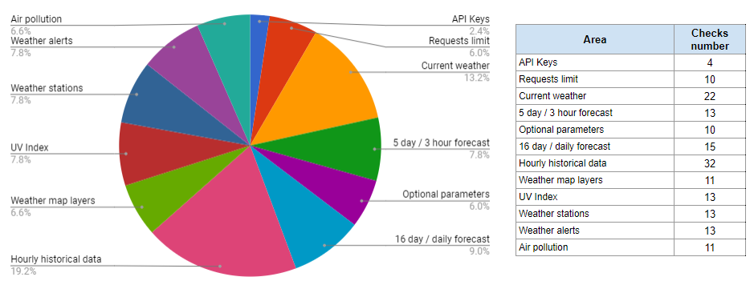

**2) The number of executed and automated checks**

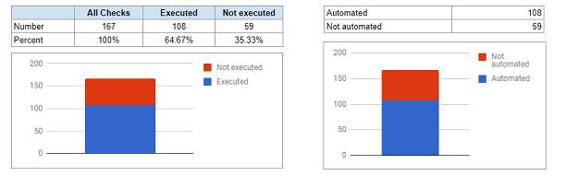

**3) Summary test results**

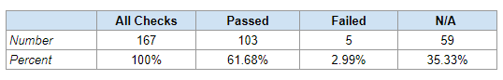

As a result, there were added into file **Test Report.docx** bug reports with descriptions and steps to reproduce.

**4) Test results by API areas**

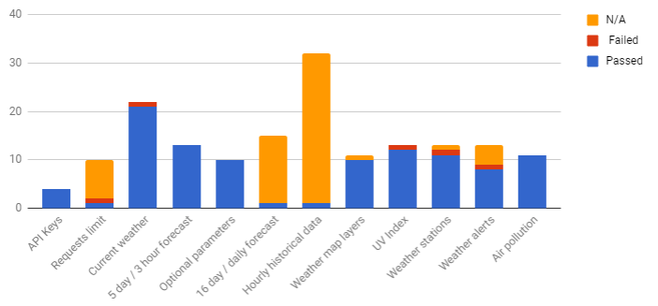

**5) The number of added bugs by severity**

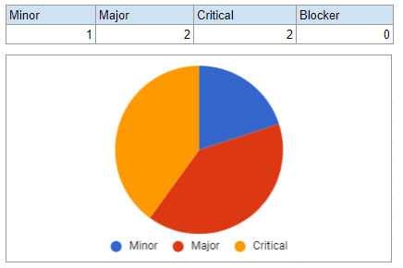

**Improvements and recommendations**

For some areas of API functionality (e.g. air pollution), there is insufficient data for cities on the server. It is recommended to connect new weather stations to collect their data.

**Conclusion**

During the testing process there were found defects in restricting requests to the server. It can harm successful server work. Also defects in access for different tariff plans were found. It can harm the business area. So, this items are need to fix ASAP.

**QA Resolution**

At first need to fix all found bugs - critical and major bugs in short time. After that need to retest all the functionalities in which bugs were found.